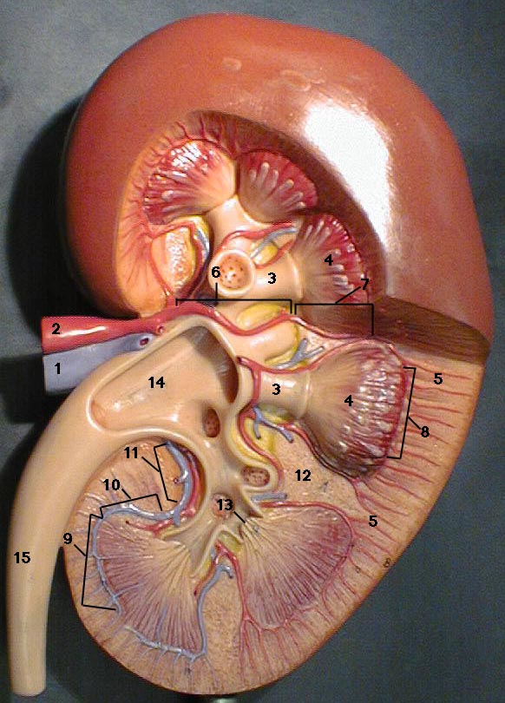
RINICHIUL
1. | Vena renala
2. | Artera renala
3. | Calixul renal
4. | Piramida medulara
5. | Corticala renala
6. | Artera segmentala
7. | Artera interlobara
8. | Artera arcuata
9. | Vena arcuata
10. | Vena interlobara
11. | Vena segmentala
12. | Coloanele renale
13. | Papilele renale
14. | Bazinetul
15. | Ureter

